SOUTHEAST UNIVERSITY
Department of Computer Science and Engineering

Online Shop Management System

PROJECT REPORT
 | Course Name | : | Introduction to Programming Language II (Java)
 | Course Code | : | CSE282.5
 | Semester | : | Summer 2026  Submission Date: 28/09/2026
Submitted To  Md Ayon Mia  Lecturer  Dept of CSE  Southeast University |  |  |  |  | Submitted By  Muhammad Sydul Islam (2024100000409)  Ainun Nahar Kona (2024100000433)  Sadia Islam Sinthya (204100000056)  Saidur Rahman Joy (2024100000246

1. Introduction

Online Shop Management System is a Java desktop application that simulates the core operations of an online store: product, customer, order, and payment management. It has a Java Swing graphical interface and stores its data in files.

The project applies the four OOP principles (encapsulation, abstraction, inheritance, and polymorphism) and includes exception handling and stock management.

I dropped the course and project-type wording since you wanted it to be only about the project. If you want it even shorter, I can cut it to two lines, or I can add this to the cover page as an abstract.

2. Objectives

- Develop a user-friendly Java Swing-based Online Shop Management System using Object-Oriented Programming concepts.
- Manage products, customers, orders, stock, and different payment methods efficiently.
- Implement Encapsulation, Abstraction, Inheritance, Polymorphism, validation, and custom exception handling.
- Maintain application data through local file storage and develop a modular, maintainable system.

3. Motivation
Online shopping has become an important part of modern commerce. Managing products, customers, orders, stock, and payments manually can become difficult as the number of transactions increases.
This project was selected to understand how a real-world shopping system can be represented using programming concepts learned in Java. It also provides practical experience with classes, inheritance, interfaces, polymorphism, exception handling, and file handling in a complete application.

4. Applications
The Online Shop Management System can be used as a simplified model of a small-scale online shopping or retail management application.

4.1 Potential Users
- Shop owners
- Small business operators
- Store managers
- Sales representatives
- Customers
- Students learning Java and OOP concepts

4.2 Practical Uses and Benefits
- Maintain product information and track stock.
- Register and manage customer information.
- Manage customer orders.
- Process different types of payments.
- Demonstrate a basic e-commerce workflow.

5. Project Description

- 5.1 Overall System Description

The Online Shop Management System is built from a set of interconnected classes, each representing one entity of a real online shop. The main entities are User, Customer, Product, Order, PaymentMethod, CashPayment, and MobilePayment. User holds the properties common to all users, and Customer extends it for shoppers. Product stores item details and stock, and Order links a customer with the products being purchased. Payments go through the PaymentMethod interface, which CashPayment and MobilePayment implement.
The MainGUI class is the main Swing window, where users manage products and customers, place orders, and choose a payment method. It connects the interface to the underlying classes, so the classes themselves stay free of interface code.

- Major class relationships:
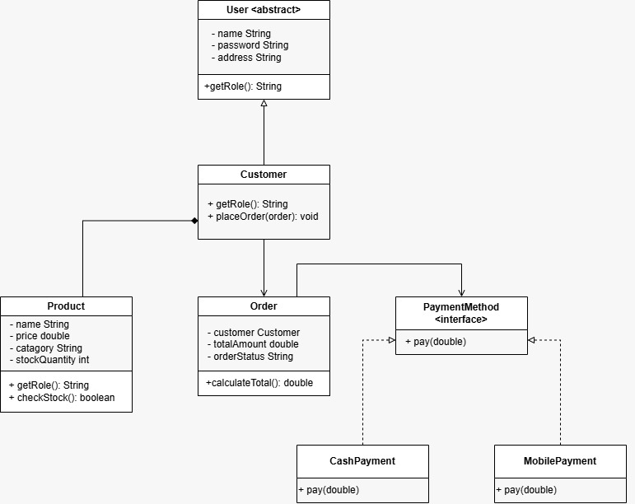

5.2 Main Features
Product Management. The system stores each product's details, including its name, price, and available stock. Products can be added, viewed, updated, and removed, and their stock is kept accurate as orders are placed.

Customer Management. Customers are registered in the system with their details. Each customer can then be linked to the orders they place, so every order can be traced back to its customer.

Order Management. An order ties together a customer, the selected products, and the chosen payment method. It is the central part of the system, bringing the other modules into one transaction.

Payment Processing. Customers can pay by Cash Payment or Mobile Payment. Both follow the same interface, so a new payment method can be added later without changing the order logic.

Stock Management. Before an order is confirmed, the system checks that enough stock is available. If it is not, the order is stopped, which prevents overselling.

Exception Handling. Invalid operations are handled with custom exceptions such as OutOfStockException. Errors are reported clearly to the user instead of crashing the application.

5.3 Major Classes
Class | Main Responsibility
Product | Stores product details such as name, price, and quantity, and updates stock when items are sold.
User | Defines the properties and behavior shared by all users of the system.
Customer | Extends User to represent a shopper and keeps track of the customer's orders.
Order | Combines a customer, the ordered products, and a payment method, and manages the order process.
PaymentMethod | Defines the common interface that every payment type must follow.
CashPayment | Implements PaymentMethod for payments made in cash.
MobilePayment | Implements PaymentMethod for payments made through mobile services.
OutOfStockException | A custom exception thrown when the requested quantity exceeds the available stock.
MainGUI | Provides the Swing interface through which users operate the whole system.

5.4 System Workflow
When the application starts, MainGUI is launched and the user can begin with product and customer management: adding the products to sell and registering the customers who will buy them. To place an order, the user selects a customer and the products, and the system checks that enough stock is available. If it is, the user selects a payment method, and the order is processed with either cash or mobile payment. After processing, the stock levels and records are updated and stored in files, so the data is kept when the program closes.

Start → Launch MainGUI → Manage Products → Manage Customers → Create Order → Check Stock → Select Payment Method → Process Order → Update/Store Data → End

5.5 Java and OOP Concepts Used
Encapsulation. Class fields are kept private and can only be read or changed through getter and setter methods. This protects the data from unintended changes and lets each class validate its own values.
Abstraction. The User class and the PaymentMethod interface define what related classes must do without fixing how they do it. Other parts of the system depend on these general definitions rather than on the details of each class.
Inheritance. Customer extends User, so it reuses the common user properties and behavior and only adds what is specific to a customer. This avoids duplicated code.
Polymorphism. CashPayment and MobilePayment both implement PaymentMethod, so an order can work with any payment type through the same interface. Which payment runs is decided at runtime.
Exception Handling. Java's try-catch mechanism, together with the custom OutOfStockException, handles invalid operations such as ordering more items than are in stock. The program can then respond with a clear message and continue running.

6. Tools & Technologies
Tool / Technology | Purpose
Java | Main programming language
Java Swing | Graphical User Interface
IntelliJ IDEA | Development environment
Git | Version control
GitHub | Source code repository
Local Files | Data persistence
The project uses standard Java functionality and does not require an external database server.

7. Output / Results

User Login:
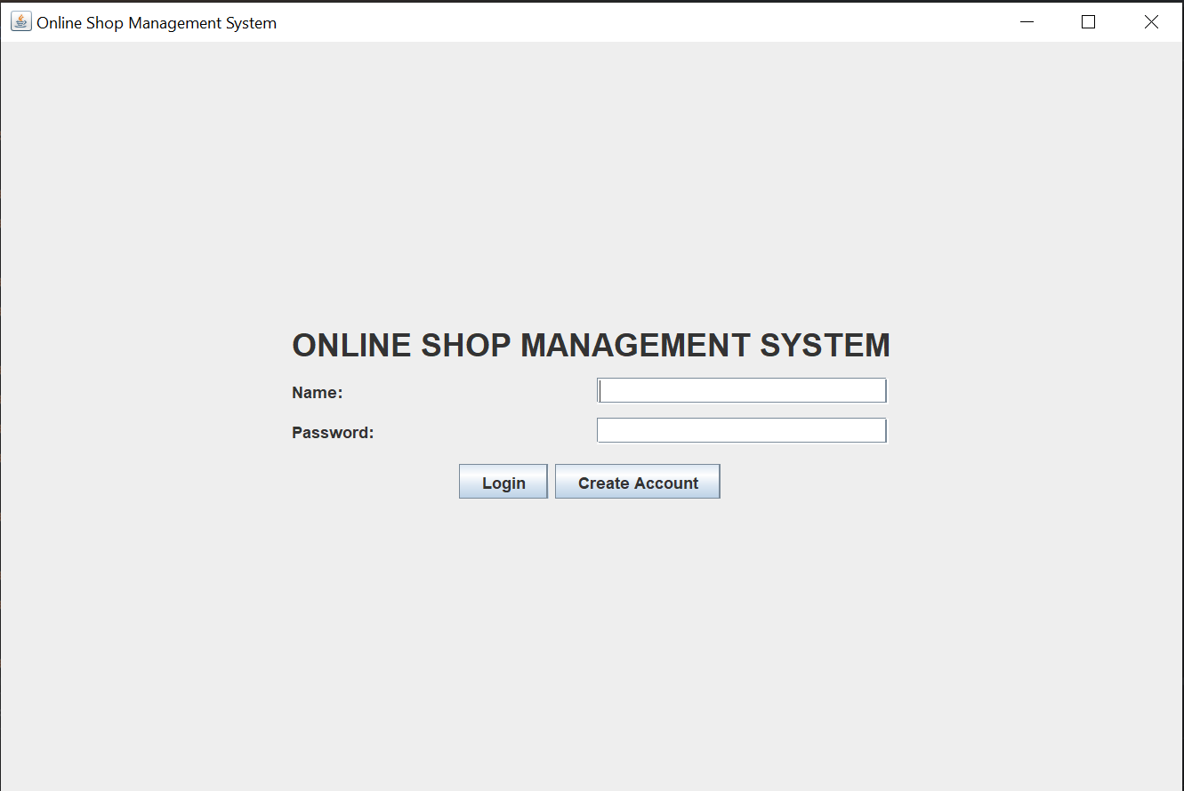

User Registration Panel:
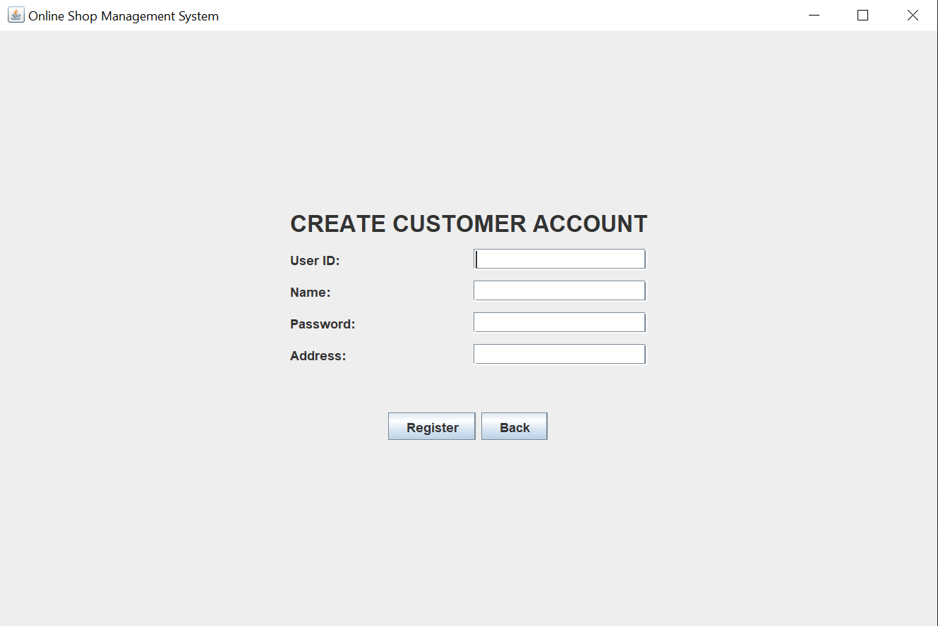

Dash Board:
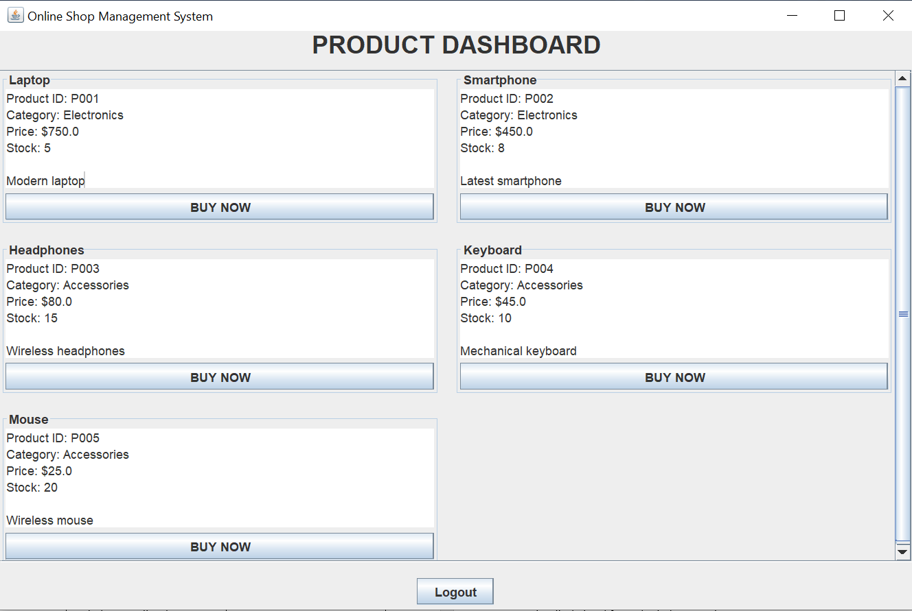

8. Contribution
Team Member | Main Contribution | Module / Feature
Muhammad Sydul Islam | Developed Order functionality and worked on overall project integration. | Order
Ainun Nahar Kona | Developed the payment interface and payment implementations. | PaymentMethod, CashPayment, MobilePayment
Saidur Rahman Joy | Developed product information, pricing, and stock management. | Product
Sadia Islam Sinthya | Developed user and customer-related functionality. | User, Customer

9. Team Members Details with Github:

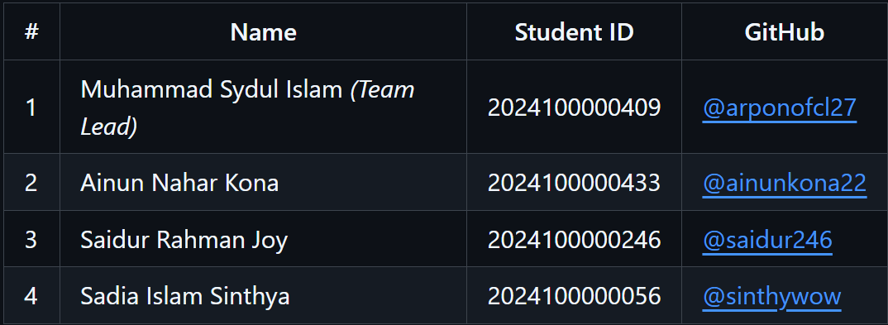

10. Conclusion
The Online Shop Management System was successfully developed as a Java-based desktop application for the CSE282 course. The project achieved its main objectives by implementing product, customer, order, and payment management functionalities within a single system.
The project provided practical experience in applying the four major Object-Oriented Programming principles: Encapsulation, Abstraction, Inheritance, and Polymorphism. It also demonstrated Java Swing GUI development, custom exception handling, and file-based data persistence.

10.1 Limitations
- Uses local file-based storage instead of a database.
- Designed as a desktop application rather than a web or mobile application.
- Limited authentication and security features.
- No real online payment gateway integration.
- Primarily designed for academic demonstration.
- System does not restart after a purchase.
- User has to login again to make a second purchase.

10.2 Future Improvements
- Integration with a database such as MySQL.
- Development of a web-based version.
- Secure user authentication.
- Integration with real payment gateways.
- Product search and filtering.
- Improved reporting and sales analytics.
- Administrator dashboard.
Cloud-based data storage and synchronization.

